Plan View

186 m

0 m

320 m

FBP X

FBP Y

FBP Z

FCS X

FCS Y

FCS Z

Fire line

Road

320 m

160 m

300 m

250 m

150 m

100 m

50 m

Devices

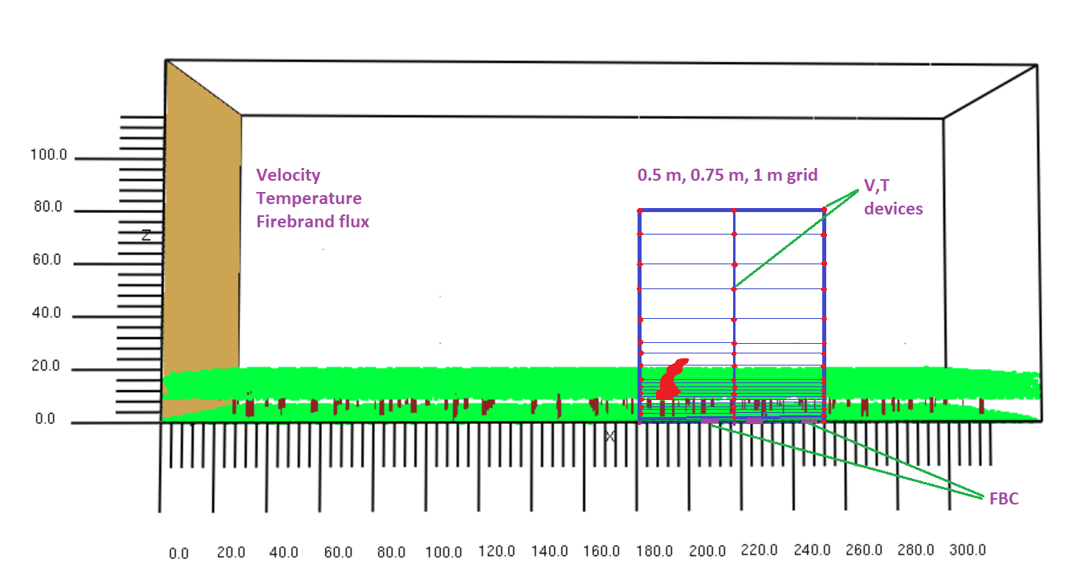

1. Graphical comparison of time series temperature data

|  |
| --- |
| X= 182 m |
| X= 217 m |
| X= 252 m |

1. Graphical comparison of time-averaged temperature data

|  |
| --- |
|  |

|  |
| --- |
|  |
|  |

\*\*Fireline is at x= 186 m

1. GCI based on time-series temperature data

|  |  |  |  |
| --- | --- | --- | --- |
|  | GCI (1.00/0.75) | | |
| Height | x=182 m | x=217 m | x=252 m |
| 0 | 20.9 | 23.4 | 28.8 |
| 5 | 5.4 | 34.6 | 15.7 |
| 10 | 11.7 | 163.4 | 16.8 |
| 15 | 22.2 | 182.3 | 62.1 |
| 20 | 17.0 | 271.0 | 60.1 |
| 30 | 5.5 | 670.3 | 80.5 |
| 40 | 3.1 | 647.8 | 102.9 |
| 50 | 1.3 | 436.2 | 177.8 |
| 60 | 1.7 | 61.3 | 409.6 |
| 70 | 2.0 | 1.3 | 353.8 |
| 80 | 0.9 | 0.8 | 361.6 |

\*\*Fire line height is 9 m above the ground

|  |
| --- |
|  |

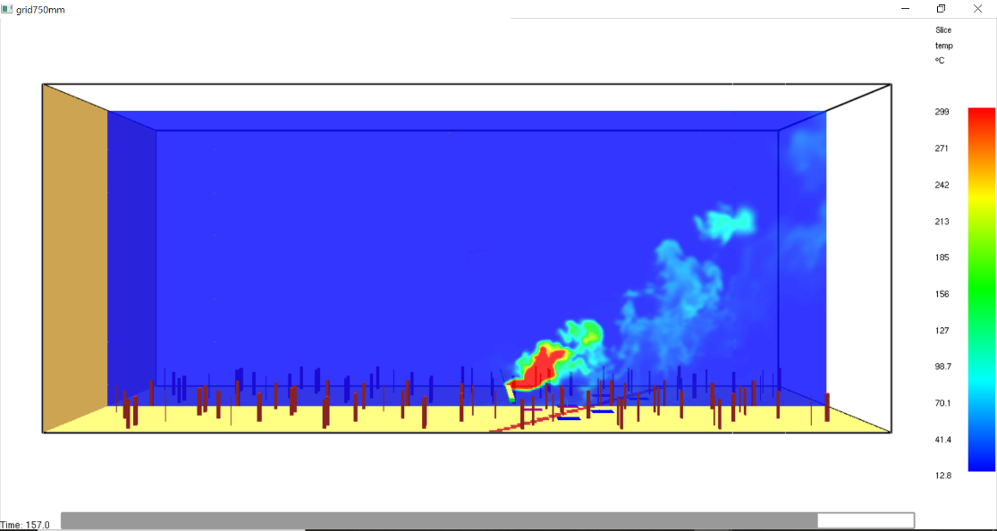

1. GCI based on time-averaged temperature data

|  |  |  |  |  |  |  |
| --- | --- | --- | --- | --- | --- | --- |
|  | Average temperature (0C ) | | | | | |
|  | 750 mm | | | 1000 mm | | |
| Height (m) | x=182 m | x=217 m | x=252 m | x=182 m | x=217 m | x=252 m |
| 0 | 14.3 | 15.1 | 14.5 | 13.7 | 14.2 | 13.6 |
| 1 | 13.8 | 15.2 | 14.4 | 13.1 | 14.3 | 13.6 |
| 2 | 13.4 | 15.1 | 14.4 | 13.0 | 14.5 | 13.6 |
| 3 | 13.2 | 15.1 | 14.4 | 12.9 | 14.5 | 13.7 |
| 4 | 13.2 | 15.1 | 14.3 | 12.9 | 14.5 | 13.8 |
| 5 | 13.2 | 15.2 | 14.3 | 12.9 | 14.5 | 13.8 |
| 6 | 13.2 | 15.5 | 14.3 | 12.9 | 14.5 | 13.8 |
| 7 | 13.2 | 15.7 | 14.3 | 12.9 | 14.6 | 13.9 |
| 8 | 13.2 | 16.0 | 14.3 | 13.0 | 14.7 | 13.9 |
| 9 | 13.4 | 17.3 | 14.3 | 13.2 | 15.0 | 13.9 |
| 10 | 13.4 | 18.4 | 14.3 | 13.2 | 15.7 | 13.9 |
| 11 | 13.6 | 19.9 | 14.3 | 13.3 | 17.0 | 13.9 |
| 12 | 14.0 | 22.1 | 14.5 | 13.2 | 18.7 | 14.0 |
| 13 | 13.9 | 23.5 | 14.5 | 13.3 | 21.0 | 14.1 |
| 14 | 13.9 | 25.1 | 14.6 | 13.3 | 23.5 | 14.3 |
| 15 | 14.1 | 27.6 | 14.7 | 13.3 | 26.5 | 14.6 |
| 16 | 13.8 | 28.8 | 14.8 | 13.4 | 29.0 | 14.8 |
| 17 | 13.8 | 30.0 | 14.9 | 13.2 | 31.1 | 15.0 |
| 18 | 13.7 | 32.2 | 15.2 | 13.0 | 32.8 | 15.0 |
| 19 | 13.7 | 32.8 | 15.4 | 13.0 | 33.4 | 15.1 |
| 20 | 13.6 | 33.7 | 15.7 | 12.9 | 33.0 | 15.2 |
| 25 | 13.5 | 36.9 | 17.1 | 13.0 | 31.8 | 16.8 |
| 30 | 13.4 | 32.1 | 18.9 | 13.0 | 33.1 | 18.1 |
| 40 | 13.2 | 25.3 | 23.1 | 13.2 | 22.4 | 20.6 |
| 50 | 13.3 | 14.9 | 23.2 | 13.3 | 16.0 | 21.3 |
| 60 | 13.2 | 13.8 | 18.1 | 13.2 | 13.5 | 18.7 |
| 70 | 13.1 | 13.3 | 16.2 | 13.2 | 13.3 | 16.6 |
| 80 | 13.2 | 13.3 | 14.2 | 13.2 | 13.3 | 15.0 |
| 90 | 13.2 | 13.3 | 13.9 | 13.2 | 13.2 | 13.7 |
| 100 | 13.1 | 13.2 | 13.3 | 13.2 | 13.2 | 13.3 |
| 110 | 13.1 | 13.2 | 13.3 | 13.1 | 13.2 | 13.3 |
| 120 | 13.2 | 13.2 | 13.3 | 13.2 | 13.2 | 13.2 |
| 130 | 13.2 | 13.2 | 13.2 | 13.2 | 13.2 | 13.2 |
| 140 | 13.3 | 13.2 | 13.2 | 13.2 | 13.2 | 13.3 |

|  |  |  |  |  |  |
| --- | --- | --- | --- | --- | --- |
| Єrms | | | GCI (0.75/1.00) | | |
| x=182 m | x= 217 m | x=252 m | x=182 m | x= 217 m | x=252 m |
| 0.34328 | 0.071376 | 0.038473 | 132.4 | 27.5 | 14.8 |

Velocity profile at Y=0, after initiating fire

|  |
| --- |
|  |

Firebrand flux

|  |  |  |  |
| --- | --- | --- | --- |
| location | Firebrand flux (pcs/m2.s) | | Difference (%) |
| Grid 750 mm | Grid 1000 mm |
| FCS X | 0.0302 | 0.0395 | 23.5 |
| FCS Y | 0.2732 | 0.5149 | 46.9 |
| FCS Z | 0.9921 | 0.7552 | 23.8 |

Single tree burning firebrand mass (pan by pan) for different grids.

|  |  |  |  |  |
| --- | --- | --- | --- | --- |
| Pan number | 37.5 mm | 50 mm | 75 mm | 100 mm |
| 1 | 1.613 | 1.455 | 1.450 | 0.000 |
| 2 | 1.650 | 3.173 | 1.184 | 2.547 |
| 3 | 1.466 | 0.530 | 2.148 | 0.730 |
| 4 | 1.363 | 0.714 | 1.090 | 0.614 |
| 5 | 0.885 | 3.641 | 1.853 | 1.360 |
| 6 | 0.000 | 0.658 | 0.721 | 2.188 |
| 7 | 0.000 | 0.000 | 0.000 | 1.218 |
| 8 | 1.693 | 1.937 | 2.894 | 2.394 |
| 9 | 2.512 | 1.872 | 1.956 | 1.058 |
| 10 | 0.355 | 2.819 | 1.705 | 1.881 |
| 11 | 4.170 | 0.861 | 1.590 | 2.707 |
| 12 | 1.897 | 0.642 | 0.000 | 0.000 |
| 13 | 1.091 | 0.163 | 0.678 | 0.366 |
| 14 | 1.091 | 0.163 | 0.678 | 0.366 |
| total | 19.786 | 18.630 | 17.945 | 17.428 |

|  |  |
| --- | --- |
|  | C:\Users\s4620106\OneDrive\dgl_results analysis\results\To milestone report\new images\layoutDimensions.JPG |